Loss Function

**What’s a Loss Function?**

It’s a method of evaluating how well your algorithm models your dataset.

If your predictions are totally off, your loss function will output a higher number.

If they’re pretty good, it’ll output a lower number.

As you change pieces of your algorithm to try and improve your model, your loss function will tell you if you’re getting anywhere.

In fact, we can design our own (very) basic loss function to further explain how it works.

For each prediction that we make, our loss function will simply measure the absolute difference between our prediction and the actual value.

In mathematical notation, it might look something like *abs(y_predicted – y).* Here’s what some situations might look like if we were trying to predict how expensive the rent is in some NYC apartments:

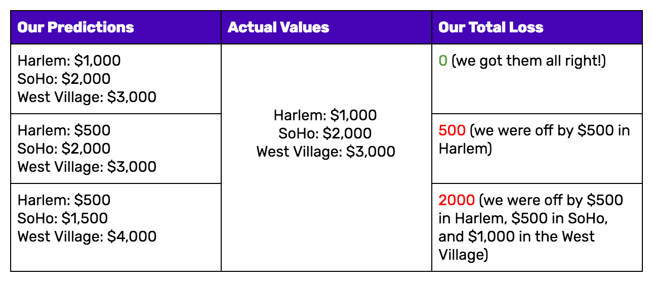

Notice how in the loss function *we* defined, it doesn’t matter if our predictions were too high or too low. All that matters is how incorrect we were, directionally agnostic. This is *not* a feature of all loss functions: in fact, your loss function will vary significantly based on the domain and unique context of the problem that you’re applying machine learning to.

In your project, it may be much worse to guess too high than to guess too low, and the loss function you select must reflect that.

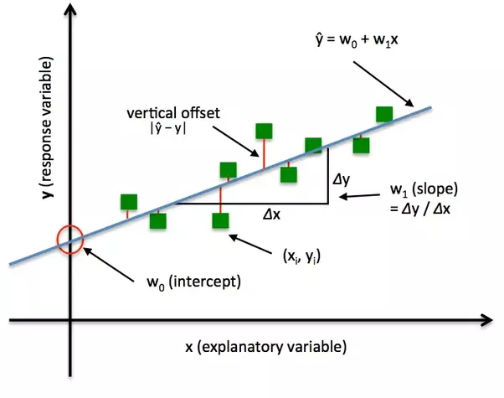

**Different Types and Flavours of Loss Functions**

A lot of the loss functions that you see implemented in machine learning can get complex and confusing. Consider [this paper from late 2017](https://arxiv.org/abs/1711.11157), entitled *A Semantic Loss Function for Deep Learning with Symbolic Knowledge*. There’s more in that title that I don’t understand than I do. But if you remember the end goal of all loss functions**–measuring how well your algorithm is doing on your dataset**–you can keep that complexity in check.We’ll run through a few of the most popular loss functions currently being used, from simple to more complex.

*Mean Squared Error*

[Mean Squared Error](https://math.tutorvista.com/statistics/mean-squared-error.html) (MSE) is the workhorse of basic loss functions: it’s easy to understand and implement and generally works pretty well. To calculate MSE, you take the difference between your predictions and the ground truth, square it, and average it out across the whole dataset.

[Implemented in code](http://ml-cheatsheet.readthedocs.io/en/latest/loss_functions.html#mean-squared-error), MSE might look something like:

def MSE(y_predicted, y):

squared_error = (y_predicted - y) ** 2

sum_squared_error = np.sum(squared_error)

mse = sum_squared_error / y.size

return(mse)

*Likelihood Loss*

The [likelihood function](http://www.statisticshowto.com/likelihood-function/) is also relatively simple, and is commonly used in **classification problems**. The function takes the predicted probability for each input example and multiplies them. And although the output isn’t exactly human interpretable, it’s useful for comparing models.

For example, consider a model that outputs probabilities of [0.4, 0.6, 0.9, 0.1] for the ground truth labels of [0, 1, 1, 0]. The likelihood loss would be computed as (0.6) * (0.6) * (0.9) * (0.9) = 0.2916. Since the model outputs probabilities for TRUE (or 1) only, when the ground truth label is 0 we take (1-p) as the probability. In other words, we multiply the model’s outputted probabilities together for the actual outcomes.

*Log Loss (Cross Entropy Loss)*

[Log Loss](http://wiki.fast.ai/index.php/Log_Loss) is a loss function also used frequently in classification problems, and is one of the most popular measures for [Kaggle](https://www.kaggle.com/) competitions. It’s just a straightforward modification of the likelihood function with logarithms.



This is actually exactly the same formula as the regular likelihood function, but with logarithms added in. You can see that when the actual class is 1, the second half of the function disappears, and when the actual class is 0, the first half drops. That way, we just end up multiplying the log of the actual predicted probability for the ground truth class.

The cool thing about the log loss loss function is that is has a kick: it penalizes heavily for being *very confident* and *very wrong*. Predicting high probabilities for the wrong class makes the function go crazy. The graph below is for when the true label =1, and you can see that it skyrockets as the predicted probability for label = 0 approaches 1.

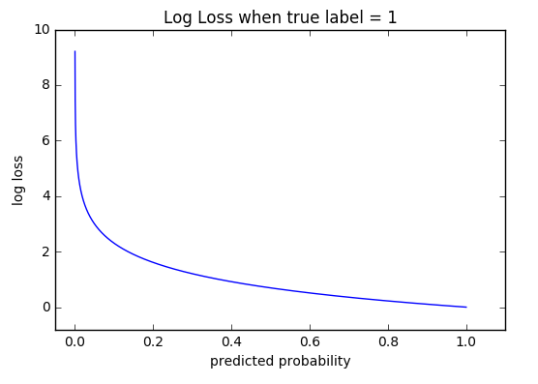

**Loss Functions and Optimizers**

Loss functions provide more than just a static representation of how your model is performing–they’re how your algorithms fit data in the first place.

Most machine learning algorithms use some sort of loss function in the process of optimization, or finding the best parameters (weights) for your data.

For a simple example, consider [linear regression](https://onlinecourses.science.psu.edu/stat501/node/251). In traditional “least squares” regression, the line of best fit is determined through none other than MSE (hence the least squares moniker)!

For each set of weights that the model tries, the MSE is calculated across all input examples. The model then optimizes the MSE functions––or in other words, makes it the lowest possible––through the use of an optimizer algorithm like [Gradient Descent](https://towardsdatascience.com/gradient-descent-in-a-nutshell-eaf8c18212f0).

Just like there are different flavors of loss functions for unique problems, there is no shortage of different optimizers as well. That’s beyond the scope of this post, but in essence, the loss function and optimizer work in tandem to fit the algorithm to your data in the best way possible.

Machines learn by means of a loss function. It’s a method of evaluating how well specific algorithm models the given data. If predictions deviates too much from actual results, loss function would cough up a very large number.

Gradually, with the help of some optimization function, loss function learns to reduce the error in prediction.

There’s no one-size-fits-all loss function to algorithms in machine learning.

There are various factors involved in choosing a loss function for specific problem such as type of machine learning algorithm chosen, ease of calculating the derivatives and to some degree the percentage of outliers in the data set.

Broadly, loss functions can be classified into two major categories depending upon the type of learning task we are dealing with — **Regression losses and Classification losses.**

In **classification**, we are trying to predict output from set of finite categorical values i.e Given large data set of images of hand written digits, categorizing them into one of 0–9 digits. Regression, on the other hand, deals with predicting a continuous value for example given floor area, number of rooms, size of rooms, predict the price of room.

NOTE

n - Number of training examples.

i - ith training example in a data set.

y(i) - Ground truth label for ith training example.

y_hat(i) - Prediction for ith training example.

Regression Losses

Mean Square Error/Quadratic Loss/L2 Loss

Mathematical formulation :-

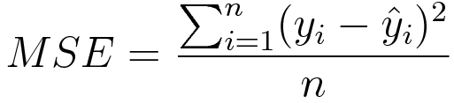

Mean Squared Error

As the name suggests, Mean square error is measured as the average of squared difference between predictions and actual observations. It’s only concerned with the average magnitude of error irrespective of their direction.

However, due to squaring, predictions which are far away from actual values are penalized heavily in comparison to less deviated predictions. Plus MSE has nice mathematical properties which makes it easier to calculate gradients.

import numpy as np

y_hat = np.array([0.000, 0.166, 0.333])

y_true = np.array([0.000, 0.254, 0.998])

def rmse(predictions, targets):

differences = predictions - targets

differences_squared = differences ** 2

mean_of_differences_squared = differences_squared.mean()

rmse_val = np.sqrt(mean_of_differences_squared)

return rmse_val

print("d is: " + str(["%.8f" % elem for elem in y_hat]))

print("p is: " + str(["%.8f" % elem for elem in y_true]))

rmse_val = rmse(y_hat, y_true)

print("rms error is: " + str(rmse_val))

Mean Absolute Error/L1 Loss

Mathematical formulation :-

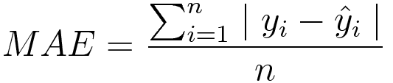

Mean absolute error

Mean absolute error, on the other hand, is measured as the average of sum of absolute differences between predictions and actual observations. Like MSE, this as well measures the magnitude of error without considering their direction. Unlike MSE, MAE needs more complicated tools such as linear programming to compute the gradients. Plus MAE is more robust to outliers since it does not make use of square.

import numpy as np

y_hat = np.array([0.000, 0.166, 0.333])

y_true = np.array([0.000, 0.254, 0.998])

print("d is: " + str(["%.8f" % elem for elem in y_hat]))

print("p is: " + str(["%.8f" % elem for elem in y_true]))

def mae(predictions, targets):

differences = predictions - targets

absolute_differences = np.absolute(differences)

mean_absolute_differences = absolute_differences.mean()

return mean_absolute_differences

mae_val = mae(y_hat, y_true)

print ("mae error is: " + str(mae_val))

Mean Bias Error

This is much less common in machine learning domain as compared to it’s counterpart. This is same as MSE with the only difference that we don’t take absolute values. Clearly there’s a need for caution as positive and negative errors could cancel each other out. Although less accurate in practice, it could determine if the model has positive bias or negative bias.

Mathematical formulation :-

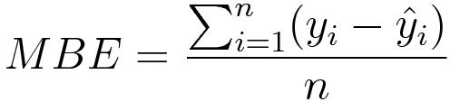

Mean bias error

Classification Losses

Hinge Loss/Multi class SVM Loss

In simple terms, the score of correct category should be greater than sum of scores of all incorrect categories by some safety margin (usually one). And hence hinge loss is used for [maximum-margin](https://link.springer.com/chapter/10.1007/978-0-387-69942-4_10) classification, most notably for [support vector machines](https://en.wikipedia.org/wiki/Support_vector_machine). Although not [differentiable](https://ipfs.io/ipfs/QmXoypizjW3WknFiJnKLwHCnL72vedxjQkDDP1mXWo6uco/wiki/Differentiable_function.html), it’s a convex function which makes it easy to work with usual convex optimizers used in machine learning domain.

Mathematical formulation :-

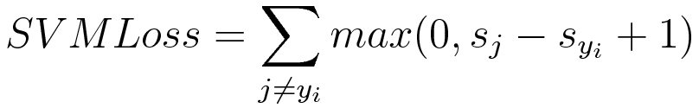

SVM Loss or Hinge Loss

Consider an example where we have three training examples and three classes to predict — Dog, cat and horse. Below the values predicted by our algorithm for each of the classes :-

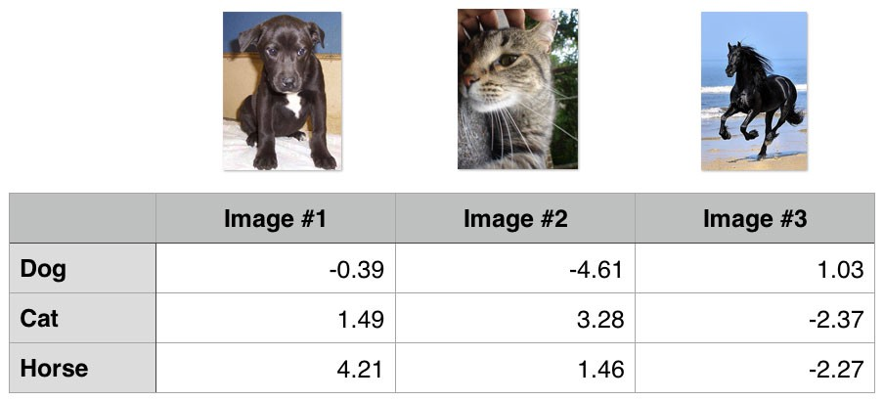

Hinge loss/ Multi class SVM loss

Computing hinge losses for all 3 training examples :-

## 1st training example

max(0, (1.49) - (-0.39) + 1) + max(0, (4.21) - (-0.39) + 1)

max(0, 2.88) + max(0, 5.6)

2.88 + 5.6

8.48 (High loss as very wrong prediction)

## 2nd training example

max(0, (-4.61) - (3.28)+ 1) + max(0, (1.46) - (3.28)+ 1)

max(0, -6.89) + max(0, -0.82)

0 + 0

0 (Zero loss as correct prediction)

## 3rd training example

max(0, (1.03) - (-2.27)+ 1) + max(0, (-2.37) - (-2.27)+ 1)

max(0, 4.3) + max(0, 0.9)

4.3 + 0.9

5.2 (High loss as very wrong prediction)

Cross Entropy Loss/Negative Log Likelihood

This is the most common setting for classification problems. Cross-entropy loss increases as the predicted probability diverges from the actual label.

Mathematical formulation :-



Cross entropy loss

Notice that when actual label is 1 (y(i) = 1), second half of function disappears whereas in case actual label is 0 (y(i) = 0) first half is dropped off. In short, we are just multiplying the log of the actual predicted probability for the ground truth class. An important aspect of this is that cross entropy loss penalizes heavily the predictions that are confident but wrong.

import numpy as np

predictions = np.array([[0.25,0.25,0.25,0.25],

[0.01,0.01,0.01,0.96]])

targets = np.array([[0,0,0,1],

[0,0,0,1]])

def cross_entropy(predictions, targets, epsilon=1e-10):

predictions = np.clip(predictions, epsilon, 1. - epsilon)

N = predictions.shape[0]

ce_loss = -np.sum(np.sum(targets * np.log(predictions + 1e-5)))/N

return ce_loss

cross_entropy_loss = cross_entropy(predictions, targets)

print ("Cross entropy loss is: " + str(cross_entropy_loss))